**Server OU’s**

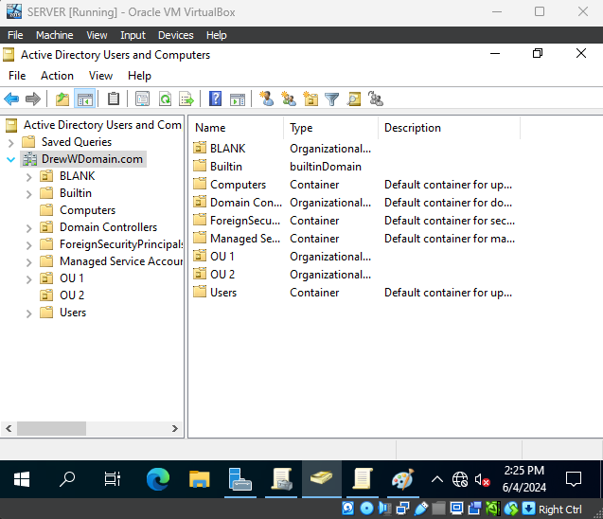

This screenshot shows the two OU’s created within the DrewWDomain.com domain.

**User 1**

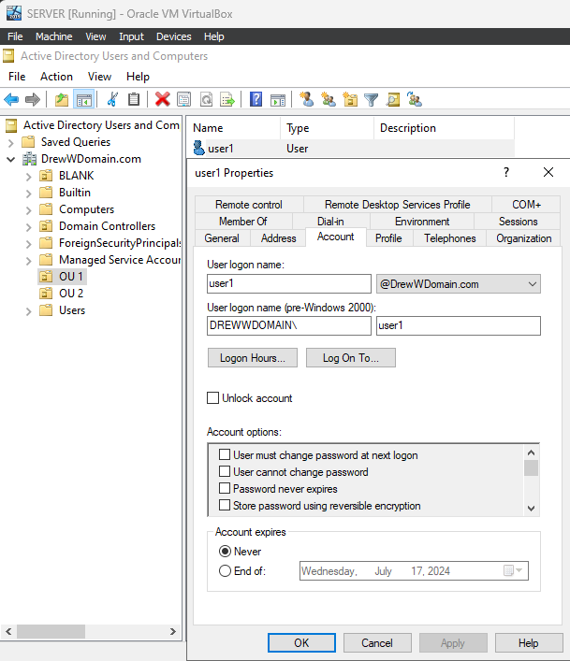

This screenshot shows User1 placed in OU 1, joined to the DrewWDomain.com domain.

**User 2**

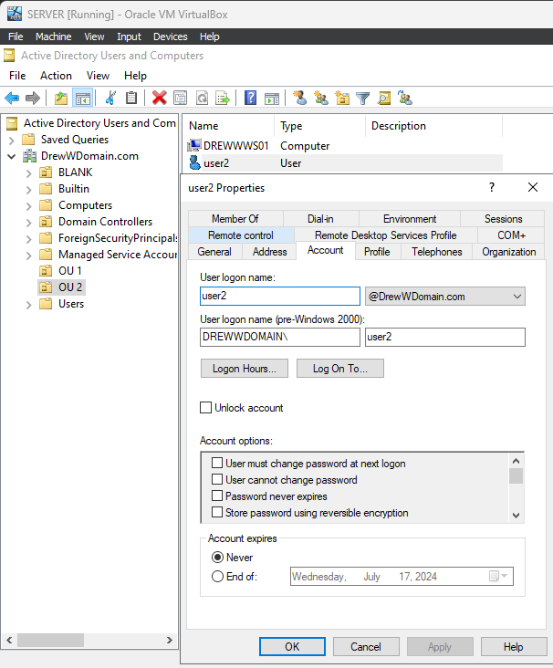

This screenshot shows User2 placed in OU 2, joined to the DrewWDomain.com domain.

**OU 1 Settings**

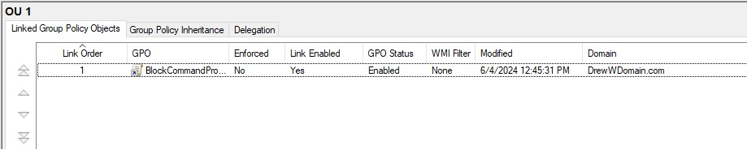

This screenshot shows the BlockCommandPrompt policy in OU 1.

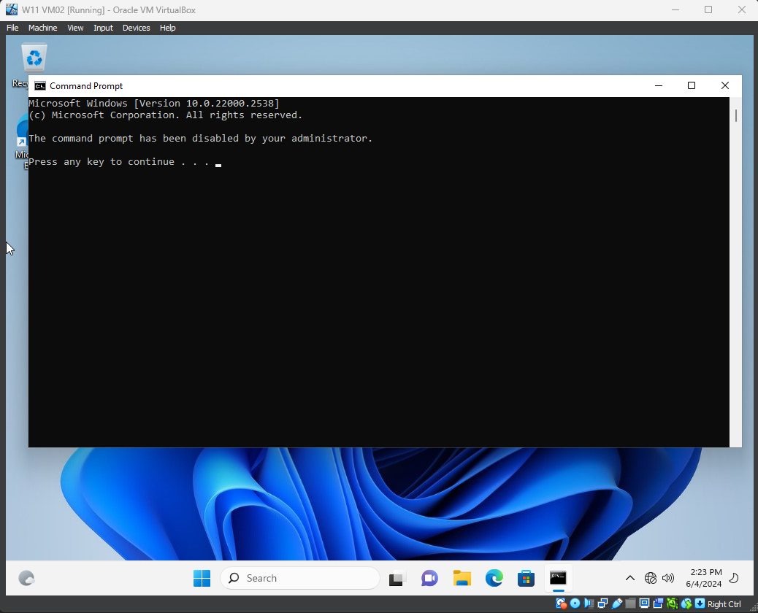

This screenshot shows the command prompt blocked.

**OU 2 Settings**

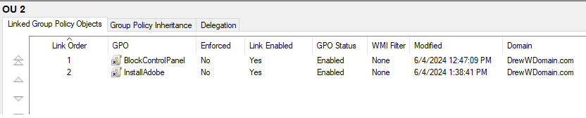

This screenshot shows the BlockControlPanel setting and the InstallAdobe setting in OU 2.

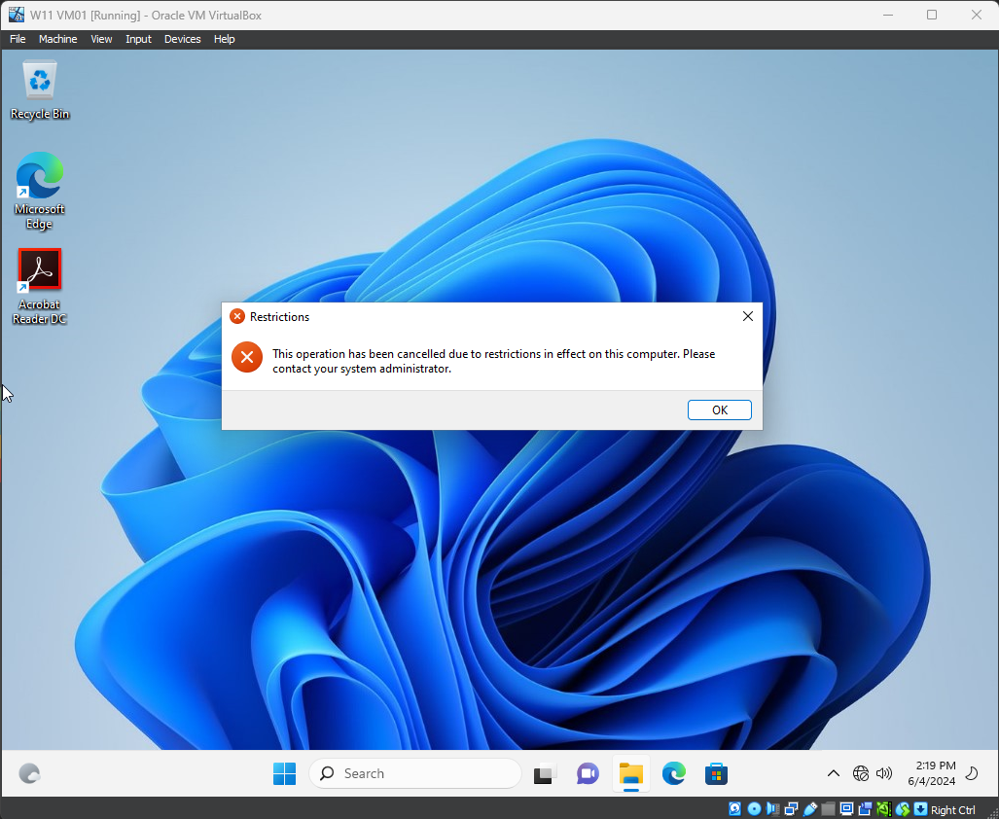

This screenshot shows the control panel blocked.

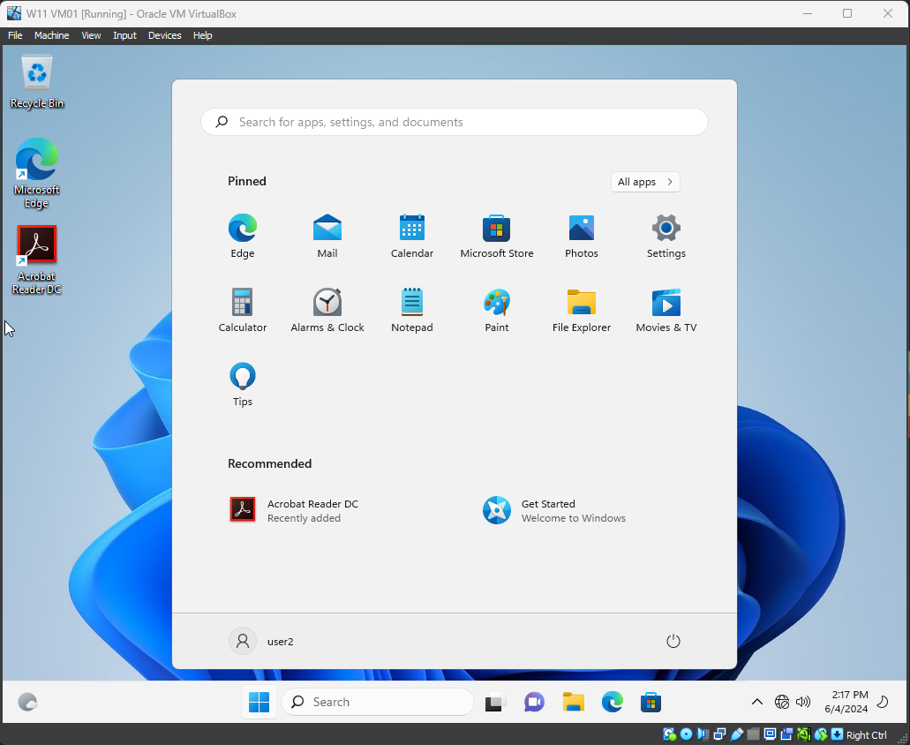

This screenshot shows that Adobe installed automatically